WIOA REGIONAL PLAN

Capital Region

Frederick County MD

Montgomery County MD

Prince George’s County MD

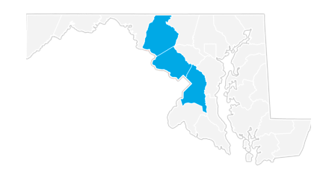

April, 2017

Table of Contents
Section 1 – Regional Analysis 3
Section 2 – Regional Sector Strategies 12
Section 3 – Regional Analysis 17
Section 4 – Regional Sector Strategies 19
Section 5 – Regional Analysis 21
Section 6 – Regional Sector Strategies 23
Section 7 – Regional Analysis 24

Section 1 – Regional Analysis

Region Definition - The Capital Region is defined as the following counties: Frederick County, Maryland; Montgomery County, Maryland; Prince George’s County, Maryland.

- Sector Analysis

The largest sector in the Capital Region is Health Care and Social Assistance, employing 117,390 workers. The next-largest sectors in the region are Professional, Scientific, and Technical Services (111,105 workers) and Retail Trade (102,511). High location quotients (LQs) indicate sectors in which a region has high concentrations of employment compared to the national average. The sectors with the largest LQs in the region are Public Administration (LQ = 2.12), Professional, Scientific, and Technical Services (1.76), and Construction (1.36).

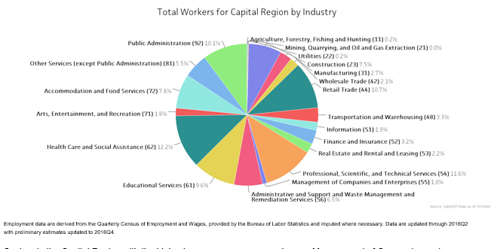

Sectors in the Capital Region with the highest average wages per worker are Management of Companies and Enterprises ($135,191), Finance and Insurance ($105,924), and Information ($98,058). Regional sectors with the best job growth (or most moderate job losses) over the last 5 years are Health Care and Social Assistance (+12,526 jobs), Accommodation and Food Services (+10,158), and Educational Services (+5,835).

Over the next 10 years, employment in the Capital Region is projected to expand by 57,457 jobs. The fastest growing sector in the region is expected to be Health Care and Social Assistance with a +2.1% year-over-year rate of growth. The strongest forecast by number of jobs over this period is expected for Health Care and Social Assistance (+26,784 jobs), Professional, Scientific, and Technical Services (+13,617), and Construction (+7,964).

- Demographic Profile

In 2015, the population in the Capital Region was 2,194,973. Between 2005 and 2015, the region’s population grew at an annual average rate of 1.0%. The region has a civilian labor force of 1,220,015 with a labor force participation rate of 71.5%. Of individuals 25 to 64 in the Capital Region, 45.8% have a bachelor’s degree or higher which compares with 31.3% in the nation.
The median household income in the Capital Region is $87,469 and the median house value is $358,017.

Summary
 | Percent |  |  | Value
 | Capital Region | MD | USA | Capital Region | MD | USA
Demographics
Population⁶ | — | — | — | 2,194,973 | 6,006,401 | 321,418,820
Population Annual Average Growth⁶ | 1.0% | 0.7% | 0.8% | 19,897 | 41,402 | 2,590,222
Median Age^{2,4} | — | — | — | 37.0 | 38.0 | 37.2
Under 18 Years⁴ | 24.1% | 23.4% | 24.0% | 498,573 | 1,352,964 | 74,181,467
18 to 24 Years⁴ | 9.4% | 9.7% | 9.9% | 193,459 | 557,360 | 30,672,088
25 to 34 Years⁴ | 13.8% | 13.2% | 13.3% | 285,565 | 762,042 | 41,063,948
35 to 44 Years⁴ | 14.5% | 13.8% | 13.3% | 299,356 | 795,572 | 41,070,606
45 to 54 Years⁴ | 15.5% | 15.6% | 14.6% | 320,869 | 902,204 | 45,006,716
55 to 64 Years⁴ | 11.8% | 12.1% | 11.8% | 243,564 | 695,768 | 36,482,729
65 to 74 Years⁴ | 6.1% | 6.7% | 7.0% | 126,701 | 386,357 | 21,713,429
75 Years, and Over⁴ | 4.9% | 5.6% | 6.0% | 100,495 | 321,285 | 18,554,555
Race: White⁴ | 44.2% | 58.2% | 72.4% | 914,723 | 3,359,284 | 223,553,265
Race: Black or African American⁴ | 36.0% | 29.4% | 12.6% | 744,083 | 1,700,298 | 38,929,319
Race: American Indian and Alaska Native⁴ | 0.4% | 0.4% | 0.9% | 8,627 | 20,420 | 2,932,248
Race: Asian⁴ | 8.7% | 5.5% | 4.8% | 179,569 | 318,853 | 14,674,252
Race: Native Hawaiian and Other Pacific Islander⁴ | 0.1% | 0.1% | 0.2% | 1,170 | 3,157 | 540,013
Race: Some Other Race⁴ | 7.2% | 3.6% | 6.2% | 147,972 | 206,832 | 19,107,368
Race: Two or More Races⁴ | 3.5% | 2.9% | 2.9% | 72,438 | 164,708 | 9,009,073
Hispanic or Latino (of any race)⁴ | 15.1% | 8.2% | 16.3% | 311,505 | 470,632 | 50,477,594

Economic
Labor Force Participation Rate and Size (civilian population 16 years and over) | 71.5% | 67.9% | 63.3% | 1,220,015 | 3,214,531 | 158,897,824
Armed Forces Labor Force | 0.4% | 0.6% | 0.4% | 6,567 | 26,691 | 1,015,464
Veterans, Age 18-64 | 5.3% | 6.3% | 5.5% | 73,581 | 238,765 | 10,750,884
Median Household Income² | — | — | — | $87,469 | $74,551 | $53,889
Per Capita Income² | — | — | — | $40,969 | $36,897 | $28,930
Poverty Level (of all people) | 7.9% | 10.0% | 15.5% | 168,042 | 576,805 | 47,749,043
Households Receiving Food Stamps | 8.0% | 10.9% | 13.2% | 61,010 | 236,656 | 15,399,651
Mean Commute Time (minutes) | — | — | — | 35.4 | 32.3 | 25.9
Commute via Public Transportation | 14.9% | 9.0% | 5.1% | 166,601 | 265,615 | 7,362,038
Union Membership³ | 11.7% | 11.2% | 11.1% | — | — | —
Educational Attainment, Age 25-64
No High School Diploma | 10.2% | 9.1% | 11.8% | 121,789 | 292,670 | 19,736,243
High School Graduate | 19.4% | 24.3% | 26.4% | 230,330 | 783,948 | 43,982,863
Some College, No Degree | 18.6% | 20.2% | 21.7% | 221,611 | 650,671 | 36,187,232
Associate's Degree | 6.0% | 6.9% | 8.8% | 71,130 | 221,617 | 14,742,654
Bachelor's Degree | 23.8% | 22.0% | 19.9% | 282,964 | 709,558 | 33,245,950
Postgraduate Degree | 22.0% | 17.6% | 11.4% | 262,046 | 568,844 | 18,952,103
Housing
Total Housing Units | — | — | — | 805,518 | 2,410,256 | 133,351,840
Median House Value (of owner-occupied units)² | — | — | — | $358,017 | $286,900 | $178,600
Homeowner Vacancy | 1.2% | 1.7% | 1.9% | 6,009 | 25,604 | 1,492,691
Rental Vacancy | 5.0% | 6.6% | 6.4% | 14,110 | 51,112 | 2,949,366
Renter-Occupied Housing Units (% of Occupied Units) | 34.6% | 33.2% | 36.1% | 262,796 | 718,727 | 42,214,214
Occupied Housing Units with No Vehicle Available (% of Occupied Units) | 8.0% | 9.4% | 9.1% | 61,052 | 202,669 | 10,628,474
Social
Enrolled in Grade 12 (% of total population) | 1.5% | 1.4% | 1.4% | 31,779 | 85,877 | 4,451,334
Disconnected Youth⁵ | 2.2% | 2.9% | 3.0% | 2,475 | 9,226 | 518,859
Children in Single Parent Families (% of all children) | 34.1% | 35.6% | 34.8% | 164,317 | 457,991 | 24,408,909
Disabled, Age 18-64 | 6.4% | 8.4% | 10.3% | 88,657 | 312,042 | 19,985,588
Disabled, Age 18-64, Labor Force Participation Rate and Size | 53.7% | 47.2% | 41.0% | 47,599 | 147,296 | 8,185,456
Foreign Born | 25.3% | 14.5% | 13.2% | 544,273 | 857,804 | 41,717,420
Speak English Less Than Very Well (population 5 yrs and over) | 11.4% | 6.4% | 8.6% | 229,375 | 357,588 | 25,410,756

Source: JobsEQ® 1. ACS 2011-2015, unless noted otherwise 2. Median values for certain aggregate regions (such as MSAs) may be estimated as the weighted averages of the median values from the composing counties. 3. 2014; Current Population Survey, unionstats.com, and Chmura; county- and zip-level data are best estimates based upon industry-, MSA-, and state-level data 4. Census 2010 5. Disconnected Youth are 16-19 year olds who are (1) not in school, (2) not high school graduates, and (3) either unemployed or not in the labor force.
6. Census 2015, annual average growth rate since 2005

- Occupational Snapshot

The largest major occupation group in the Capital Region is Office and Administrative Support Occupations, employing 139,458 workers. The next-largest occupation groups in the region are Sales and Related Occupations (92,069 workers) and Food Preparation and Serving Related Occupations (74,765). High location quotients (LQs) indicate occupation groups in which a region has high concentrations of employment compared to the national average. The major groups with the largest LQs in the region are Life, Physical, and Social Science Occupations (LQ = 2.33), Computer and Mathematical Occupations (1.40), and Business and Financial Operations Occupations (1.35).

Occupation groups in the Capital Region with the highest average wages per worker are Management Occupations ($128,400), Legal Occupations ($118,400), and Computer and Mathematical Occupations ($94,700). The unemployment rate in the region varied among the major groups from 1.2% among Legal Occupations to 6.4% among Food Preparation and Serving Related Occupations.

Over the next 10 years, the fastest growing occupation group in the Capital Region is expected to be Healthcare Support Occupations with a +2.2% year-over-year rate of growth. The strongest forecast by number of jobs over this period is expected for Healthcare Practitioners and Technical Occupations (+8,914 jobs) and Healthcare Support Occupations (+6,569). Over the same period, the highest replacement demand (occupation demand due to retirements and workers moving from one occupation to another) is expected in Office and Administrative Support Occupations (30,515 jobs) and Sales and Related Occupations (29,823).
Occupation Snapshot in Capital Region
 |  | Current |  |  |  |  | Historical |  |  |  | Forecast
 |  | Four Quarters Ending with 2016q4 |  |  | 2016q3 |  | Total Change over the Last 5 Years | Avg Ann % Chg in Empl 2011q4-2016q4 |  |  | Over the Next 10 Years
SOC | Title | Empl | Avg. Annual Wages¹ | LQ | Unempl | Unempl Rate | Empl | Capital Region | Maryland | USA | Current Online Job Ads² | Total Repl Demand | Total Growth Demand | Avg. Annual Growth Percent
11-0000 | Management Occupations | 60,379 | $128,400 | 1.04 | 1,356 | 1.8% | 1,992 | 0.7% | 1.0% | 1.5% | 4,045 | 19,417 | 3,729 | 0.6%
13-0000 | Business and Financial Operations Occupations | 63,197 | $83,300 | 1.35 | 2,665 | 3.0% | 676 | 0.2% | 0.8% | 1.7% | 3,513 | 13,629 | 4,286 | 0.7%
15-0000 | Computer and Mathematical Occupations | 37,045 | $94,700 | 1.40 | 1,402 | 2.8% | -1,226 | -0.6% | 0.9% | 2.6% | 6,627 | 5,860 | 4,885 | 1.2%
17-0000 | Architecture and Engineering Occupations | 21,575 | $92,800 | 1.35 | 463 | 1.7% | -701 | -0.6% | 0.0% | 1.2% | 1,054 | 5,383 | 574 | 0.3%
19-0000 | Life, Physical, and Social Science Occupations | 17,874 | $84,400 | 2.33 | 408 | 1.9% | 856 | 1.0% | 0.8% | 1.2% | 1,373 | 5,292 | 511 | 0.3%
21-0000 | Community and Social Service Occupations | 14,526 | $53,800 | 0.95 | 509 | 2.6% | 1,233 | 1.8% | 0.8% | 1.7% | 509 | 3,212 | 1,062 | 0.7%
23-0000 | Legal Occupations | 9,317 | $118,400 | 1.23 | 194 | 1.2% | 327 | 0.7% | -0.1% | 0.4% | 198 | 1,860 | 357 | 0.4%
25-0000 | Education, Training, and Library Occupations | 62,400 | $59,300 | 1.15 | 3,021 | 4.4% | 3,635 | 1.2% | 0.5% | 0.6% | 1,128 | 13,629 | 5,494 | 0.8%
27-0000 | Arts, Design, Entertainment, Sports, and Media Occupations | 17,655 | $62,800 | 1.05 | 881 | 3.7% | 439 | 0.5% | 0.5% | 1.3% | 1,054 | 6,196 | 506 | 0.3%
29-0000 | Healthcare Practitioners and Technical Occupations | 51,328 | $81,800 | 0.95 | 974 | 1.5% | 3,801 | 1.6% | 1.3% | 1.6% | 2,843 | 11,914 | 8,914 | 1.6%
31-0000 | Healthcare Support Occupations | 26,437 | $32,000 | 0.94 | 1,311 | 4.2% | 2,498 | 2.0% | 1.7% | 2.3% | 1,097 | 6,015 | 6,569 | 2.2%
33-0000 | Protective Service Occupations | 20,118 | $53,600 | 1.08 | 1,049 | 3.5% | -161 | -0.2% | 0.5% | 1.0% | 793 | 4,653 | 106 | 0.1%
35-0000 | Food Preparation and Serving Related Occupations | 74,765 | $24,400 | 0.90 | 6,199 | 6.4% | 9,809 | 2.9% | 2.6% | 3.0% | 3,919 | 28,670 | 3,798 | 0.5%
37-0000 | Building and Grounds Cleaning and Maintenance Occupations | 43,479 | $27,600 | 1.25 | 2,583 | 4.8% | 1,962 | 0.9% | 1.4% | 1.1% | 1,074 | 9,941 | 2,236 | 0.5%
39-0000 | Personal Care and Service Occupations | 39,359 | $28,700 | 1.02 | 1,863 | 4.0% | 3,118 | 1.7% | 1.9% | 2.4% | 2,258 | 11,717 | 4,691 | 1.1%
41-0000 | Sales and Related Occupations | 92,069 | $40,400 | 0.92 | 4,461 | 4.3% | 1,740 | 0.4% | 0.7% | 1.4% | 7,799 | 29,823 | 2,043 | 0.2%
43-0000 | Office and Administrative Support Occupations | 139,458 | $40,400 | 0.97 | 7,137 | 4.0% | 3,321 | 0.5% | 1.0% | 1.7% | 5,464 | 30,515 | 178 | 0.0%
45-0000 | Farming, Fishing, and Forestry Occupations | 1,273 | $35,800 | 0.21 | 96 | 5.3% | -112 | -1.7% | 0.4% | 1.5% | 41 | 540 | -58 | -0.5%
47-0000 | Construction and Extraction Occupations | 52,937 | $46,600 | 1.24 | 2,508 | 4.6% | 3,871 | 1.5% | 1.8% | 2.4% | 639 | 9,950 | 5,561 | 1.0%
49-0000 | Installation, Maintenance, and Repair Occupations | 36,935 | $50,700 | 1.01 | 1,455 | 3.4% | 1,354 | 0.7% | 1.0% | 1.7% | 1,630 | 9,002 | 1,879 | 0.5%
51-0000 | Production Occupations | 26,176 | $39,300 | 0.44 | 1,685 | 5.4% | 838 | 0.7% | 0.1% | 1.4% | 700 | 6,748 | -601 | -0.2%
53-0000 | Transportation and Material Moving Occupations | 51,209 | $35,200 | 0.79 | 3,630 | 6.2% | 4,404 | 1.8% | 1.8% | 2.2% | 1,865 | 12,776 | 912 | 0.2%
00-0000 | Total - All Occupations | 959,510 | $55,400 | 1.00 | n/a | n/a | 43,675 | 0.9% | 1.1% | 1.7% | 49,623 | 246,743 | 57,631 | 0.6%
Source: JobsEQ®
Data as of 2016Q4 unless noted otherwise
Note: Figures may not sum due to rounding.
1. Occupation wages are as of 2015 and should be taken as the average for all Covered Employment
2. Data represent found online ads active within the last thirty days in any zip code intersecting or within the selected region; data represents a sampling rather than the complete universe of postings.
Occupation employment data are estimated via industry employment data and the estimated industry/occupation mix. Industry employment data are derived from the Quarterly Census of Employment and Wages, provided by the Bureau of Labor Statistics and currently updated through 2016Q2, imputed where necessary with preliminary estimates updated to 2016Q4. Wages by occupation are as of 2015 provided by the BLS and imputed where necessary. Forecast employment growth uses national projections from the Bureau of Labor Statistics adapted for regional growth patterns.

D) Analysis of the Workforce in the Region Employment Trends

As of 2016Q4, total employment for the Capital Region was 959,510 (based on a four-quarter moving average). Over the year ending 2016Q4, employment increased 0.8% in the region.

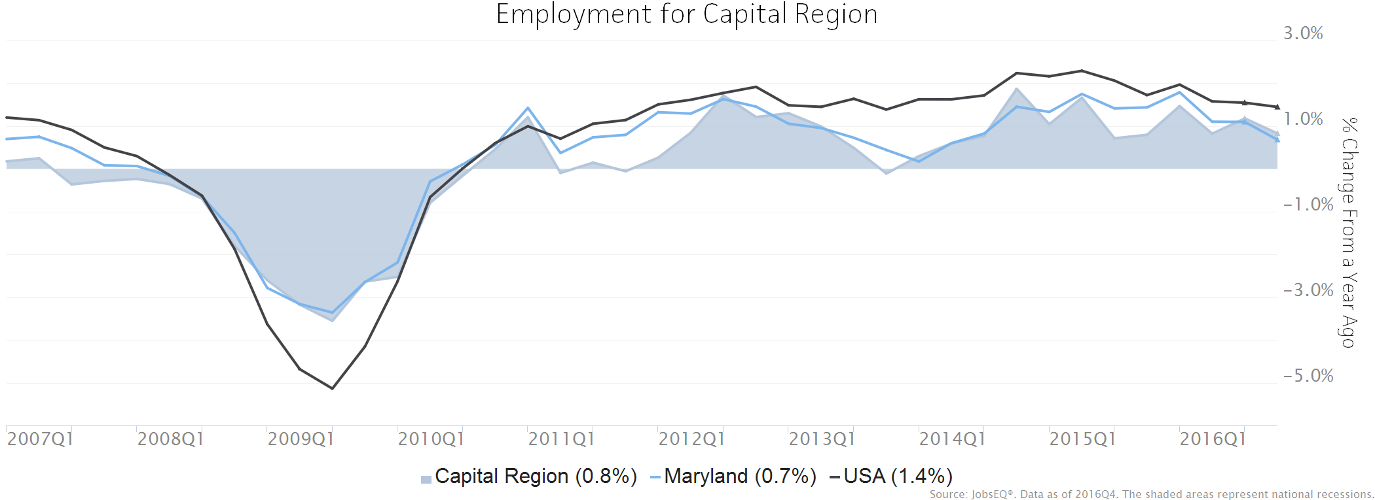
Employment data are derived from the Quarterly Census of Employment and Wages, provided by the Bureau of Labor Statistics and imputed where necessary. Data are updated through 2016Q2 with preliminary estimates updated to 2016Q4.

Unemployment Rate

The seasonally adjusted unemployment rate for the Capital Region was 3.7% as of December 2016. The regional unemployment rate was lower than the national rate of 4.9%. One year earlier, in December 2015, the unemployment rate in the Capital Region was 4.3%.

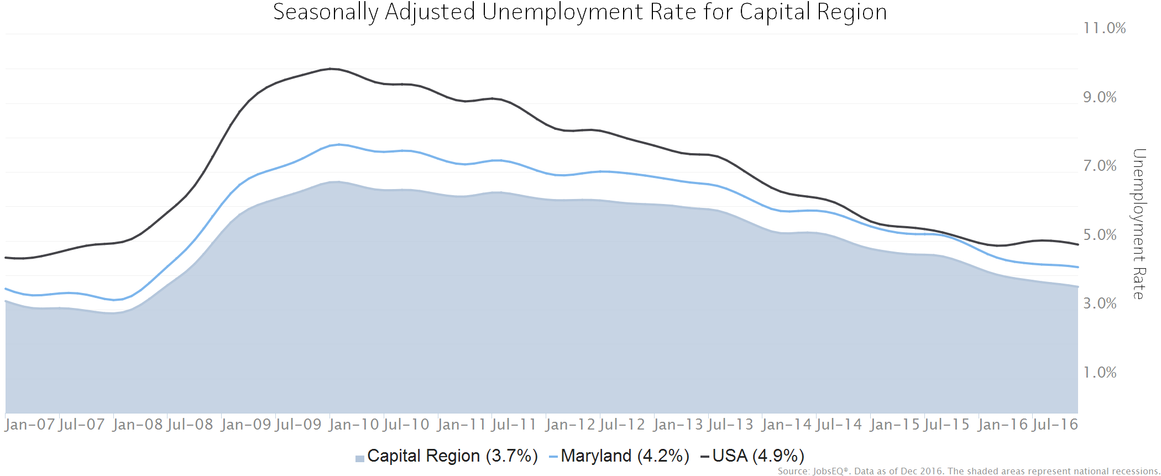
Unemployment rate data are from the Local Area Unemployment Statistics, provided by the Bureau of Labor Statistics and updated through December 2016.

Wage Trends

The average worker in the Capital Region earned annual wages of $60,466 as of 2016Q4. Average annual wages per worker increased 0.8% in the region during the preceding four quarters. For comparison purposes, annual average wages were $52,291 in the nation as of 2016Q4.
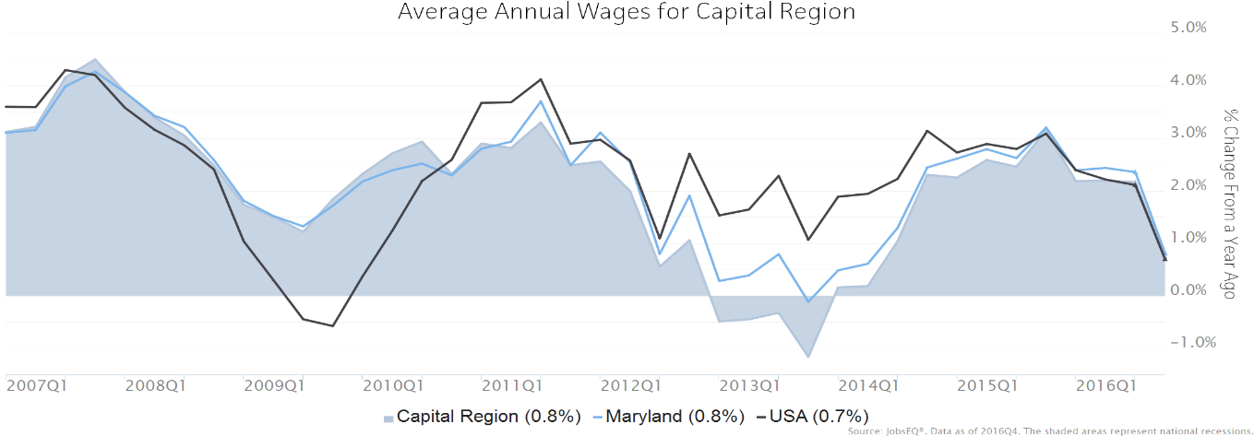
Annual average wages per worker data are derived from the Quarterly Census of Employment and Wages, provided by the Bureau of Labor Statistics and imputed where necessary. Data are updated through 2016Q2 with preliminary estimates updated to 2016Q4.

Cost of Living Index

The Cost of Living Index estimates the relative price levels for consumer goods and services. When applied to wages and salaries, the result is a measure of relative purchasing power. The cost of living is 23.4% higher in Capital Region than the U.S. average.

Cost of Living Information
 | Annual Average Salary | Cost of Living Index (Base US) | US Purchasing Power
Capital Region | $60,466 | 123.4 | $48,988
Maryland | $56,202 | 114.5 | $49,072
USA | $52,291 | 100.0 | $52,291
Source: JobsEQ®
Data as of 2016Q4
The Cost of Living Index is developed by Chmura Economics & Analytics and is updated quarterly.

Labor Market Trends

The industry cluster in the Capital Region with the highest relative concentration is Pharmaceutical with a location quotient of 2.56. This cluster employs 4,620 workers in the region with an average wage of $163,468. Employment in the Pharmaceutical cluster is projected to contract in the region about 0.2% per year over the next ten years.

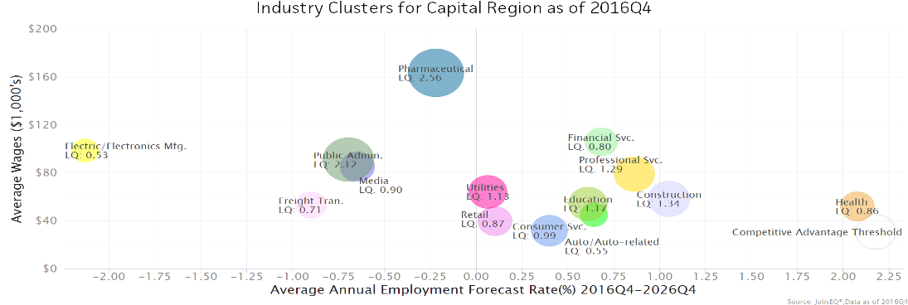

Education Levels

Expected growth rates for occupations vary by the education and training required. While all employment in the Capital Region is projected to grow 0.6% over the next ten years, occupations typically requiring a postgraduate degree are expected to grow 1.1% per year, those requiring a bachelor’s degree are forecast to grow 0.8% per year, and occupations typically needing a 2-year degree or certificate are expected to grow 1.0% per year.

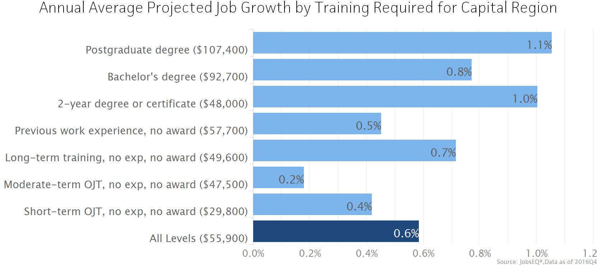

Section 2 – Regional Sector Strategies

Frederick, Montgomery and Prince George’s counties all enjoy a favorable and strategic position within the Capital Region. Its diverse economy and industry base have proven to be strong economic drivers for sustained job growth.
Frederick County is Maryland’s largest county in size—663 square miles. The City of Frederick, the county seat, is intersected by five interstate and national highways that provide easy access to Baltimore (46 miles), Washington, DC (44 miles), Gettysburg, PA (32 miles), Harpers Ferry, WV (21 miles), and Leesburg, VA (25 miles). Frederick County has the second largest concentration of biotech companies in the state, with over 80 biotech firms calling the county home. There is a strong network of local support for industry and business success.

Frederick County’s 9,000+ businesses employ 96,944 people. Nearly 120 of these businesses have 100 or more workers. Major employers represent a diverse industry base, including, bio-pharma, professional, technical and scientific, manufacturing, healthcare, and construction. Recent expansions of anchor businesses in the biopharma and current and projected growth in professional, technical and scientific industries show that the local economy continues to grow.

In addition to these industries, Frederick County has long been recognized for its strong agricultural base which remains influential in the area and offers emerging opportunities that connect restaurant and retail businesses that are capitalizing on the “farm to glass” and “farm to table” trends.

Based on data, stakeholder feedback, and keeping economic self-sufficiency in mind, Frederick’s local area priority industries for workforce development, training, and career pathway planning for 2016-2020 will include:

- Professional, Technical and Scientific
- Healthcare and Social Assistance
- Manufacturing/Advanced Manufacturing
- Construction/Trades
- Administrative and Support and Waste Management and Remediation Services
- Warehouse, Transportation and Logistics (emerging)

Prince George’s County is a diverse, high-value, and continually expanding county with an equally diverse economy. Unique in location, Prince George’s County borders the nation’s capital, Washington, D.C., and is home to numerous federal agencies including the Internal Revenue Service, Census Bureau, NASA Goddard, and Joint Base Andrews. Prince George’s County also borders Alexandria, Virginia and several large counties in Maryland: Montgomery, Anne Arundel and Howard. The County’s surroundings have given way to a well-developed transportation and mass transit network in the metropolitan areas and express access to two major transit hubs: Ronald Reagan Washington National Airport and Union Station.
Located in Prince George’s County, National Harbor is a mixed-use waterfront development and home to MGM National Harbor Resort, Gaylord National Resort & Convention Center, Tanger Outlets and a host of restaurants, hotels, retail shops, apartments and businesses. Once fully developed the National Harbor area is estimated to host over 10,000 employment opportunities. The National Harbor employment opportunities will greatly increase the existing supply of accommodation/hospitality, retail and food services industry employment opportunities.
Along with the development of National Harbor, Prince George's County is home to a growing retail industry that has been sparked by the addition of Woodmore Town Center, a 245 acre mixed-use development that includes Wegmans, Costco, Best Buy, Men’s Warehouse and much more. Prince George’s will also be the home to a new regional medical center and possibly be the future home of the FBI. The additions above will be great compliments to the home of the Washington Redskins, FedEx Field in Landover.
The Prince George’s County Workforce Development Board has identified the following industries as the primary in-demand industries of focus for the Prince George’s County public workforce system:

- Transportation & Warehousing
- Retail Trade
- Health Care & Social Assistance
- Federal Government
- Professional & Business Services
- Hospitality/Accommodation and Food Services
- Construction
- Information Technology

Montgomery County is not only home to government, research, think tanks, and non-profit organizations; it is also in a region considered a top international tourism destination fueling a robust hospitality economy. Each major industry sector in the region has unique characteristics and opportunities.
WorkSource Montgomery identifies key industries by analyzing growth patterns, local industry concentrations, and projected labor needs in family-sustaining occupations, and then facilitates Industry Alliances within these sectors. WorkSource Montgomery pulls together employers, training providers, and key community and industry stakeholders to develop industry-led solutions to meet the unique needs of Montgomery County’s high-growth industries.
Solutions include customized training for entry-level workers, career pathways for incumbent workers, industry-specific recruitment strategies, professional development, industry awareness campaigns, and other customized solutions.
Industry Alliances are currently formed in:
- Construction
- Cybersecurity/IT
- Healthcare
- Hospitality
- BioScience

In summary the following chart shows the industries that the Capital Region collectively identifies as priorities:

Industry Sector | Frederick County | Montgomery County | Prince George’s  County
Professional, Scientific, Technical | X | X | X
Healthcare | X | X | X
Construction | X | X | X

Regional Collaboration
The Capital Region partners currently enjoy the following collaborations:
Maryland Tech Connection
Maryland Tech Connection (MTC) is a public private initiative comprised of a coalition of 59 partners led by Anne Arundel Workforce Development Corporation (AAWDC). MTC seeks to support the talent acquisition and retention needs of IT and bioscience businesses and assist long-term unemployed and underemployed professionals' transition to occupations within these high-demand industries.

MTC is making a positive impact on these talent issues by effectively connecting businesses with qualified junior to high-level candidates through direct hire or train-to-hire opportunities. MTC's geographic areas of coverage include Baltimore City and the Counties of Anne Arundel, Baltimore, Calvert, Carroll, Cecil, Charles, Frederick, Harford, Howard, Montgomery, Prince George’s, and St. Mary’s.

MTC brings the following services and solutions to businesses and candidates in the Capital Region:
Businesses
- Talent pipeline development strategies
- Temp to perm/work and learn options with incentives
- Industry and training connections
Candidates
- Revitalize a job search
- Industry and training connections
- Support getting back on your feet
- Work experience opportunities

America’s Promise Grant
In 2015, the U.S. Department of Labor announced the availability of approximately $100 million in America’s Promise Job-Driven Grants to develop and grow regional partnerships between workforce agencies, education and training providers, and employers in various industries such as information technology, healthcare, and advanced manufacturing. Montgomery College is one of 23 regional workforce partnerships in 28 states to be awarded funding from the U.S. Department of Labor Employment and Training Administration (DOLETA) from this competition. The $5.6 million grant will allow Montgomery College to partner with Frederick Community College and Prince George’s Community College to offer intensive short-term trainings (boot camps) aimed at providing a pipeline of skilled IT and cybersecurity workers for local companies thus helping employers and employees thrive in the global economy. The demand for workers in cybersecurity is critical, with almost 20,000 jobs in Maryland going unfilled for lack of qualified workers.

The grant program is designed to increase opportunities for American workers through tuition-free training for high-skilled occupations and industries. WorkSource Montgomery, Frederick County Workforce Services, and Prince George’s Economic Development Corporation are partners in this grant and will leverage the opportunities it presents to support talent and skill development in IT and cybersecurity.

EARN grant programs
Several industry-led programs funded by the Maryland EARN grants are being implemented across the Capital Region. These grants bring together industry identified demands with our training organizations to provide certifications and credentials supporting the unemployed and underemployed in the region. This successful program his increased the talent pipeline significantly. Targeted industries include Healthcare, Bio-Science, and Transportation

Future Collaboration
Capital Region partners have begun to discuss ideas around collaborative industry-specific hiring events and joining efforts for training individuals for high demand occupations. It is expected that more discussions and planning around such ideas will be forthcoming in 2017-2018. Opportunities for enhanced collaboration may include:
- Local business services staff members communicating with one another about regional employer needs and opportunities, and may also conduct coordinated mass recruiting services
- Conducting regional business engagement activities, such as summits, forums, and roundtables for the targeted sectors
- Developing a regional demand occupation list, training providers list, and sharing information about the related career pathways
- Coordinating business services on a regional basis, including outreach, recruitment, and applicant referral
- Applying for workforce development grants as a regional consortium
- Aligning CTE programming across the educational institutions to align with the regions in-demand industries
- Coordinating and developing partnerships with the regions’ community based organizations to ensure wrap-around services are provided to priority populations
- Aligning business services program eligibility and processes to improve coordination of business services activities for employers operating across the region
- Innovative staffing solutions will be explored to provide staff for WIOA funded services at regional locations for all residents

Capital Region partners will continue to explore opportunities to collaborate over the next few years and are committed to assessing the needs of shared industry priorities and capacities to provide regional workforce solutions. A regional taskforce will be developed by January 2018 to identify priorities and work-plans.

Section 3- Regional Service Strategies

The Capital Region is a combination of three diverse counties and workforce areas. The demographics, economies and labor forces of each county are vastly different with varying needs. Consistent among the region are three opportunities to improve services to workforce customers, businesses, and job seekers, along with improving the efficiency of the regional workforce system:

- Creation of regional career pathways

- Development of regional sector strategies

- Improvement of connections between businesses and skilled/job ready job seekers

Capitalizing on the opportunities above will improve the efficiency, effectiveness and competitiveness of the Capital Region.

Having identified the three in-demand industries (Construction, Healthcare, and Professional, Scientific and Technical Services) the Capital Region will begin developing regional career pathways. Regional career pathways will align post-secondary training/credentials with employer-validated work readiness skills, standards and competencies to prepare and place job seekers in gainful employment. Additionally, a regional approach to career pathways will increase skills and qualifications of job seekers, align public school system and post-secondary institution programming with the needs of the business community, and increase the employment outcomes of the workforce areas.

Regional sector strategies are a necessity for the success of the Capital Region’s Career Pathways and system alignment. Along with the regions in-demand industries each County has overlapping growth industries, growth occupations and gaps in skilled job seekers. Is it pertinent that the Capital Region ensure the entire workforce system is operating in accordance with the business community. Sector strategies will help the Capital Region align the skills required by employers with the regions educational offerings and bridge the gap between job seekers and employers. The Local Workforce Development Boards have existing connections through regional grants, projects and affinity groups that will aid in the process of convening of the required partners. Along with assisting the Board in convening the required partners, the local directors will partner to ensure the sector strategies are driven by employers. Employer buy-in will lead to long term sustainability and advancement of sector strategies and career pathways in the region.

The most daunting task of the Capital Region’s service strategy will be connecting the demand and the supply of the workforce system. After the development of career pathways and sector strategies, the Capital Region must connect the labor force to the employers who are hiring in the region. Increased communication and collaborative programming by the regions business services units will help identify the real time needs of employers in the region. After effectively identifying employment opportunities the region will need to develop a strategy to connect qualified job seekers from across county lines. This will be a fluid process that may lead to innovative data sharing methods and/or workforce technology.

Section 4- Coordination with Regional Economic Development Organizations

The Capital Region has already begun collaborative activities in the IT/Cyber and Bioscience sectors with an emphasis on increasing STEM based occupations. For example, Montgomery County and Frederick County are collaborating on many activities funded through the Maryland Tech Connection. Prince George’s and Montgomery counties are collaborating with the local community colleges to support mid to high level IT/Cyber jobs through the America’s Promise grant.

Within the capital region each local board currently works closely with the local economic development entity to support business retention, expansion and attraction through various talent development activities. Given the commuter patterns within the Capital Region, future coordination goals over the next 4 years include joint training and targeted recruitment programs in targeted sectors within the region.

In order to achieve this goal, meetings with the Capital Region workforce and economic development entities will be scheduled to further explore regional talent development activities. In addition, programs and initiatives will align with Maryland Department of Labor, Licensing and Regulation (DLLR) and Department of Commerce priorities.

The Capital Region will develop plans to address potential occupational gaps identified in the graph below. A sector approach will be used to specifically address the anticipated shortage within Construction, Healthcare, Life Sciences, Education, and Office Support occupations.

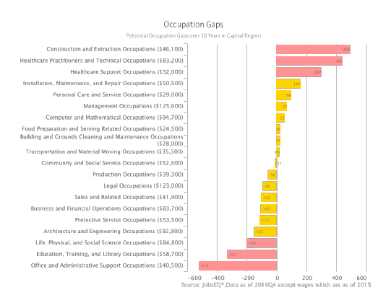

Capital Regional Economic Development Organizations

County | ED Organizations
Montgomery County | - Montgomery County Economic Development Corporation  - Rockville Economic Development Inc.  - City of Gaithersburg Economic Development  - Chambers (Regional and demographic groups)  - Latino Economic Development Center  - Small Business Development Center
Frederick County | - Frederick County office of Economic Development  - City of Frederick  - Chambers  - Small Business Development Center  - Frederick Innovative Technology Center
Prince Georges County | - Prince Georges Economic Development Corporation  - Chambers  - National Harbor Development  - Small Business Development Center

Section 5 – Coordination of Transportation and/or Other Support Services

Transportation in the Capital Region presents a challenge in workforce development.
Commuter demands to access the highly concentrated employment hubs have exceeded the
infrastructure capacity. This results in prolonged commutes as many job seekers work outside the Capital Region or must travel through congested corridors from their residence within the region through Interstates 270 or 495 and other crowded traffic routes closer the
D.C. area. Support services such a bus passes and reduced fee programs offered through the
transit system and workforce programs will continue to be offered under each local
area’s supportive services policies.

The proposed Purple Line is a 16-mile light rail line that will extend from Bethesda in
Montgomery County to New Carrollton in Prince George's County. It will provide a direct
connection to the Metrorail Red, Green and Orange Lines at Bethesda, Silver Spring, College
Park, and New Carrollton. The Purple Line will also connect to MARC, Amtrak, and local bus
services. The Purple Line will be light rail and will operate mainly in dedicated or exclusive
lanes, allowing for fast, reliable transit operations. Twenty-one stations are planned. MTA is taking the lead on this project, with the support and close coordination of a team that includes the Washington Metropolitan Area Transit Authority, Montgomery and Prince George's counties, the Maryland-National Capital Park and Planning Commission, State Highway Administration, and local municipalities in the project area.

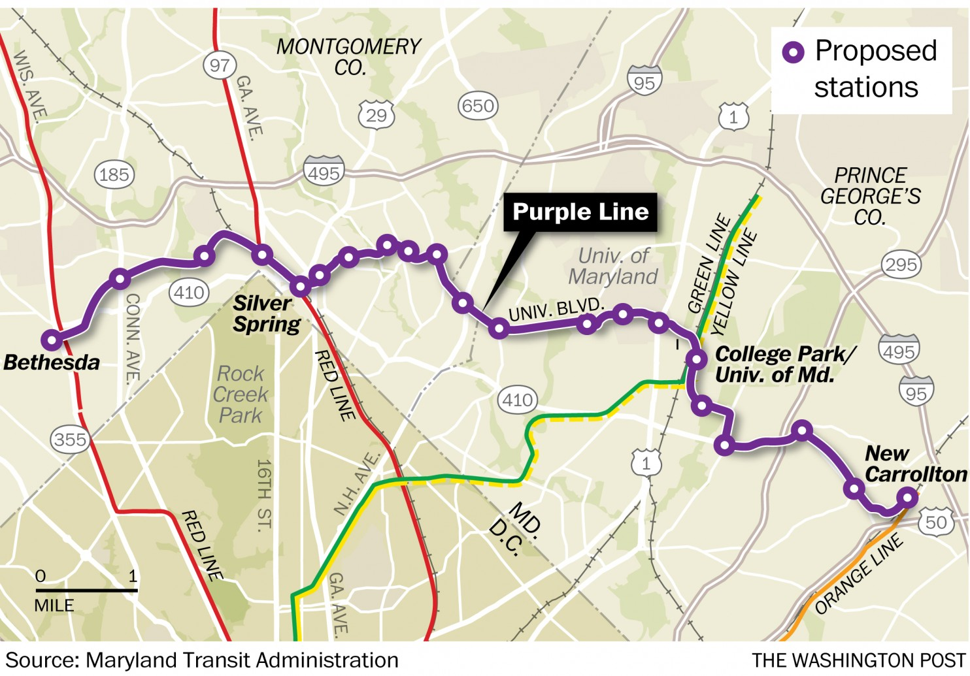

The Governor also pledged a nearly $2 billion investment in improving roads and bridges
across the state. One of the improvements would be to reduce congestion on I-270 in both
Montgomery and Frederick counties. The Capital Region views these transportation
investments as critical in order to support the diverse industries within the region and provide workers with reliable and efficient transportation options. We anticipate that infrastructure improvement will be a tremendous benefit for talent development activities throughout the region.
The specific supportive services policies for each local area are found in the individual Local WIOA Plans. At this time, the Capital Region has not adopted a Regional Supportive Services Policy. However, in an effort to better coordinate services, the three local workforce boards will explore developing regional standards. The local areas of the Capital Region may also determine on a case by case basis, that a regional strategy in supporting transportation or other supportive services is needed in order to connect workers to training and/or employment opportunities within the Region.

Section 6 - Regional Cost Arrangements

(A) Regional Cost Arrangements

Capital Region Boards will manage costs separately for common goals but will work together to align and braid funding for regional projects. Potential regional braided funding opportunities include joint recruitment events, regional cohort trainings, and supportive service agreements.

Additional joint funding opportunities exist in regional discretionary grant approaches. Currently, Frederick and Montgomery Counties coordinate funding for the Maryland Tech Connection regional grant, for example. The partnering boards will look for future opportunities to engage in regional discretionary grant projects that effectively blend funding streams.

Section 7 – Regional Performance Negotiation

At this time, we are awaiting further direction from DLLR and the Governor’s Workforce Development Board regarding performance negotiations. It is a priority for the Capital Region to be industry focused and committed to meeting the identified talent development needs.

The Capital Region looks forward to supporting priority projects as identified by the Maryland Department of Commerce and our local economic development entities. We believe that talent development will drive many of these projects and utilizing our commuter patterns and other cross regional data we will be able to widen the talent pool and coordinate our training options.

