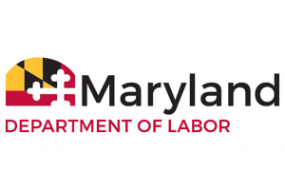
DIVISION OF LABOR AND INDUSTRY
Office of the Commissioner
1100 North Eutaw Street, room 600
Baltimore, Maryland 21201

AMUSEMENT RIDE SAFETY ADVISORY BOARD Meeting
Tuesday, November 10, 2020
11:00 a.m.
Great Frederick Fair
797 E. Patrick | Building 9
Frederick, Maryland 21701
And (Virtual meeting)

AGENDA
1. Meeting Called to Order – Glenn Fishack, Sr.
2. Roll Call
3. Approval of the minutes from the Monday, October 26, 2020 board
meeting
4. Program Update – Jim Harper
5. Regulations-
Jim Harper and Mischelle Van Reusel
6. Other Business
7. Adjournment

