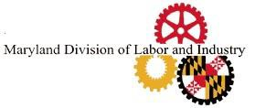

LIE DETECTOR SIGNATURE FORM

“UNDER MARYLAND LAW, AN EMPLOYER MAY NOT REQUIRE OR DEMAND, AS A CONDITION OF EMPLOYMENT, PROSPECTIVE EMPLOYMENT, OR CONTINUED EMPLOYMENT, THAT AN INDIVIDUAL SUBMIT TO OR TAKE A LIE DETECTOR OR SIMILAR TEST. AN EMPLOYER WHO VIOLATES THIS LAW IS GUILTY OF A MISDEMEANOR AND SUBJECT TO A FINE NOT EXCEEDING $100.”

Signature Date

THIS STATEMENT MUST BE ATTACHED TO ALL EMPLOYMENT APPLICATIONS IN THE STATE OF MARYLAND)

Department of Labor Division of Labor and Industry Employment Standards Service
10496 Golden West Dr. - Suite 160 Hunt Valley, MD 21031
Telephone Number: (410) 767-2357 • Fax Number: (410) 333-7303 E-mail: dldliemploymentstandards-dllr@maryland.gov

