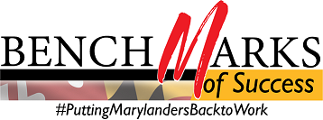

WIOA Alignment Group Meeting
Monday, April 27, 2020, 1:00 – 2:30 PM
Call-in #: 321-866-6556 / Access Code: 994-382-625‬#
‬‬‬‬‬‬‬
I. Welcome and Introductions Lauren Gilwee
II. Maryland CASH Campaign and COVID-19 Stimulus Funds Robin McKinney

III. WIOA State Plan Update Lauren Gilwee

IV. Online Learning Resources for Remote Work John Feaster

V. Organization Check-Ins re: COVID 19 Response All
- MD Labor Division of Workforce Development and Adult Learning
- MD Labor Division of Unemployment Insurance
- Governor’s Workforce Development Board
- Department of Human Services
- MSDE Division of Rehabilitation Services
- Department of Housing and Community Development
- WIOA Title I
- WIOA Title II/Community Colleges
VI. Good of the Order All

Next Meeting of the WIOA Alignment Group: Monday, June 29, 2020 (*Reminder, we opted to cancel the May session due to the Memorial Day holiday conflict)

