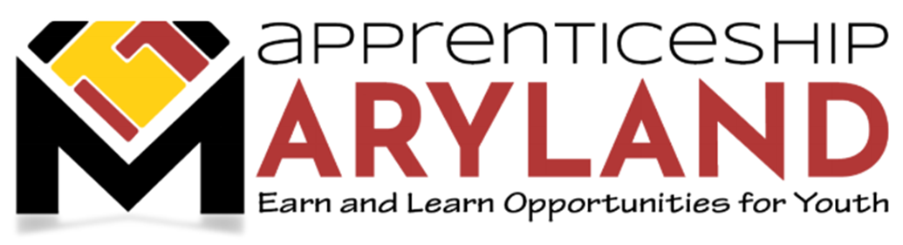
Youth Apprenticeship Advisory Committee
August 23, 2023 Meeting
Agenda

- Welcome and Introductions

- Approval of Minutes

- Discussion Regarding Status of Apprenticeship Maryland Program (AMP)

- GWDB: Executive Director introduction and update
- Overview of new Apprenticeship Grant and Salesforce
- Update on SNAP

- MSDE Update – Maryland Works Grant

- Policy Update

  - Update on AMP Policy and documents
  - Employer approval process changes

- Legislative Update

- Marketing Update

  - National Apprenticeship Week (November 13-19, 2023)
  - MSDE Panel
  - U.S. Department of Education event

- Other Business

